**Name: Saichandu Anukonti**

**Task ID: Task 1**

**GitHub Repository Link: https://github.com/Saichandu51/Task-1.git**

1. Creating and Renaming Files/Directories  
 Command  
 mkdir test_dir

cd test_dir

touch example.txt

mv example.txt renamed_example.txt

**Explanation**

* mkdir test_dir creates a new directory.
* touch example.txt creates an empty file.
* mv example.txt renamed_example.txt renames the file.

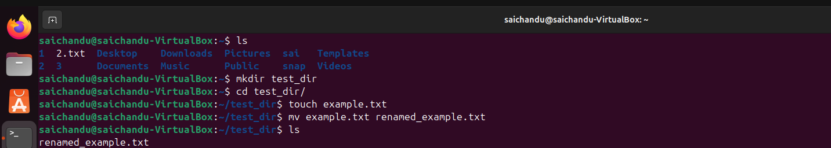

2. Viewing File Contents  
 Command  
 cat /etc/passwd

head -n 5 /etc/passwd

tail -n 5 /etc/passwd  
**Explanation**

* cat displays the entire content.
* head shows the first 5 lines.
* 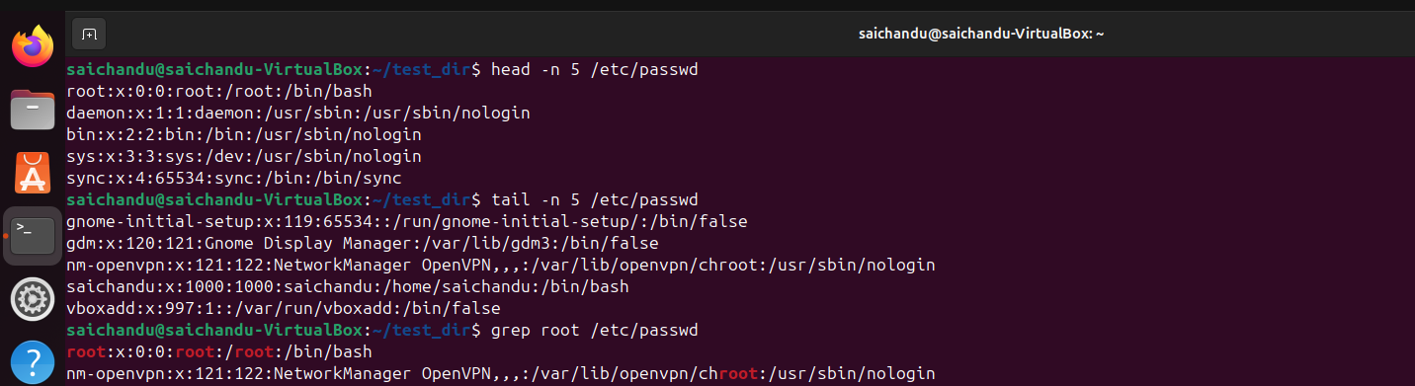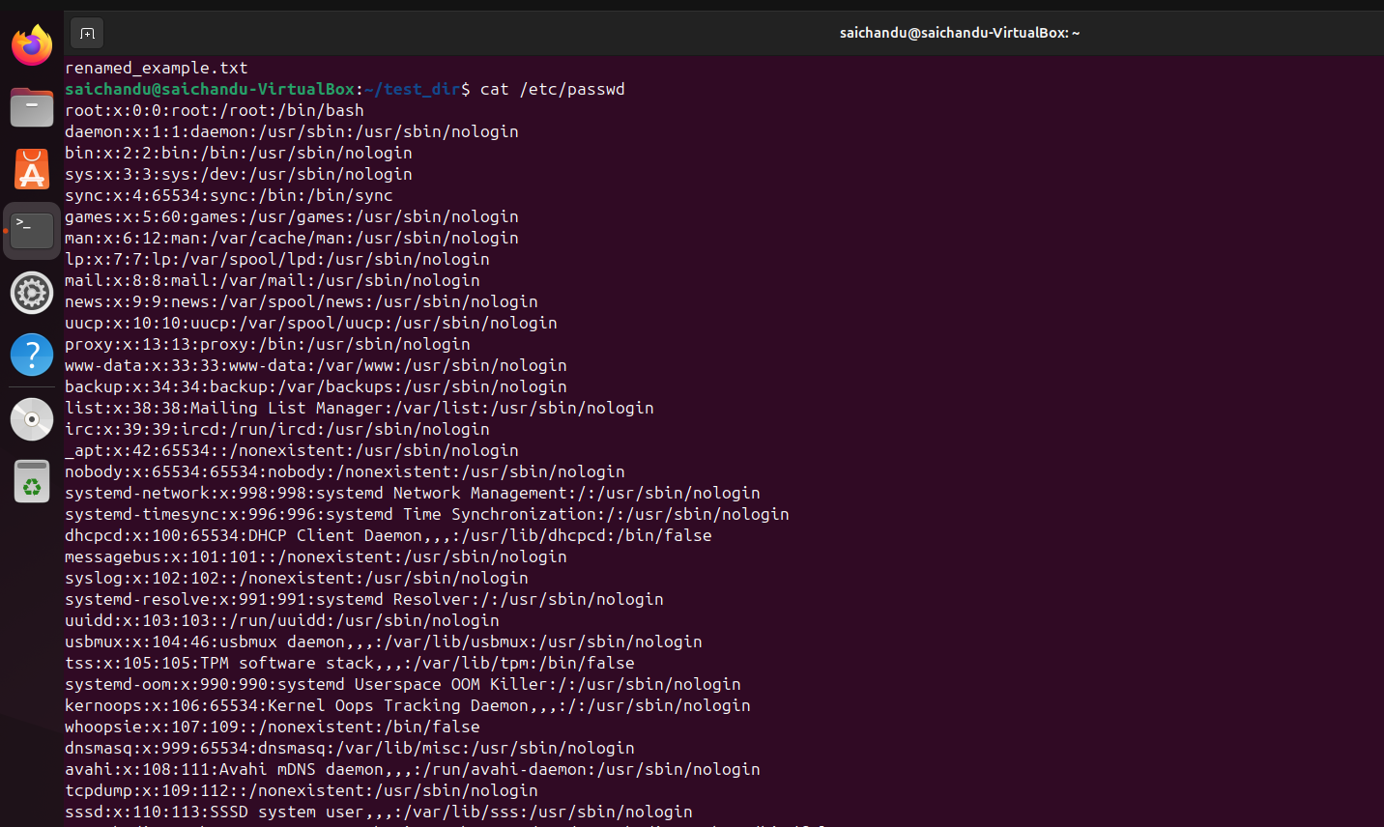tail shows the last 5 lines.

3. Searching for Patterns

Command  
 grep ‘root’ /etc/passwd

**Explanation**

* grep 'root' finds all lines that include the word **root**

4. Zipping and Unzipping

Command  
 zip -r test_dir.zip test_dir

mkdir unzipped_dir

unzip test_dir.zip -d unzipped_dir  
**Explanation**

* zip -r compresses a folder recursively.
* 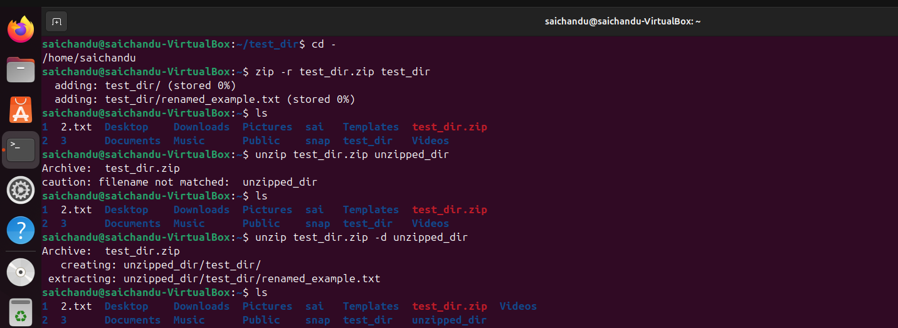unzip -d extracts the contents to a new folder.

5. Downloading Files

Command

wget <https://example.com/sample.txt>

**Explanation**

* 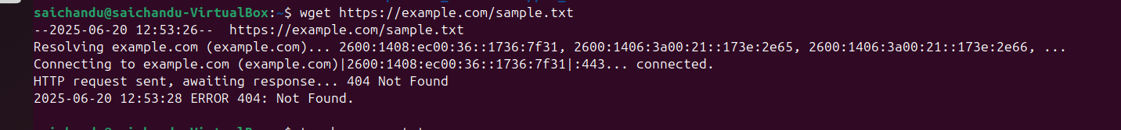wget downloads the file from the given URL.

6. Changing Permissions  
 Command  
 touch secure.txt

chmod 444 secure.txt

**Explanation**

* chmod 444 makes the file read-only for owner, group, and others.
* 4 – Read only
* 3 – Write only
* 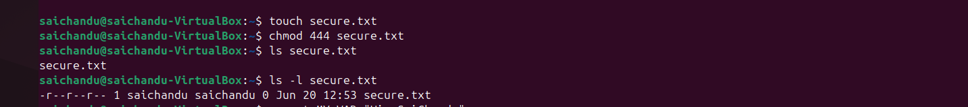1 – Execute only

7. Working with Environment Variables  
Command

export MY_VAR="Hello, Saichandu"

echo $MY_VAR

**Explanation**

* export sets an environment variable.
* 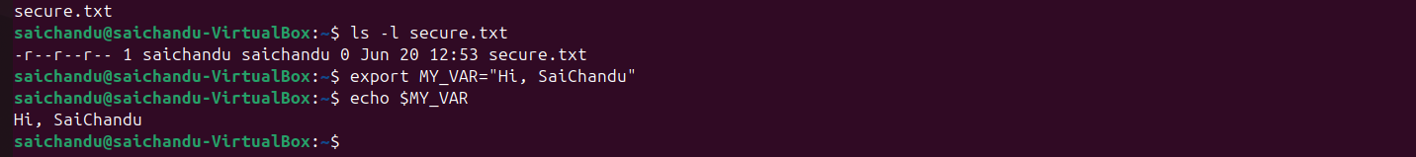echo confirms the variable is stored.